**THE TECHNICAL UNIVERSITY OF KENYA**

**RAMOGI INSTITUTE OF ADVANCED TECHNOLOGY ONLINE STUDENTS HOSTEL MANAGEMENT SYSTEM**

PRESENTED BY:

STUDENT NAME: LUCY ACHIENG WAGORO

COLLEGE NO: SCCI/08174/2016

SUPERVISED BY:

**Prof. SALESIO KIURA**

**MR EDGAR OTIENO**

**A PPROJECT REPORT SUBMITTED TO THE SCHOOL OF COMPUTING AND INFORMATION TECHNOLOGY IN PARTICIAL FULFILLEMENT FOR THE BACHELOR OF TECHNOLOGY IN COMPUTER TECHNOLOGY OF THE TECHNICAL UNIVERSITY OF KENYA**

SUBMISSION DATE:

1. **July 2021**

**DECLARATION**

I, Lucy Achieng Wagoro, declare that this project is my own original work and has not been presented by any person or group in this or any other institution for the award of certificate, diploma or degree.

NAME: Lucy Achieng Wagoro

REG. NO: SCCI/08174/2016

DATE: …………………….…………………..

SIGN: ……………………...…………………..

SUPERVISORS

DATE: …………………..…………………..

SIGN: ……………………...…………………..

**DEDICATION**

I bestow this project proposal to my loving husband Dr. N. Mbuge, my lovely son Shalom Destiny and my two beautiful daughters, Shammah Victory and Nissi Faveur

You are the purpose of my hard work

**ACKNOWLEDGEMENT**

I express my sincere appreciation to all the people who directly and indirectly contributed to the success of development of this project. Richard Onyango Akelo, I don’t know how I would have managed without him, ‘Richie’, may God bless you abundantly. I wish to encompass my gratitude to my supervisors Prof. Salesio Kiura and Mr. Edgar Otieno, who have aggressively guided me tirelessly to achieve my best, without them, this project would have not been completed.

With lots of love, I would like to appreciate my biological parents Bishop Domnic Wagoro and Mrs. Jennipher_Njoga Wagoro for their genuine prayers towards the success of every step I make in my studies.

I sincerely thank the force behind my strength, my husband ‘DOKTARI’ who has always stood by me in prayers, counselling and financial support.

Finally, I thank the Almighty God for granting me good health, knowledge and wisdom during the exercise.

CHAPTER ONE

**1.0 INTRODUCTION**

RIAT is a public middle-level tertiary institution located in Kisumu County offering courses in the field of business, agriculture, science and technology. The courses are varied to suit K.C.P.E and K.C.S.E graduates at Artisan, Craft and Diploma levels. RIAT was established by the Luo community who agreed to start up an institution in Nyanza Province (now Kisumu County). RIAT is located on the hills 10km North of Kisumu Town and 2km off Kisumu- Kakamega highway.

Vision

The Institute’s primary objective is to equip trainees with technical and occupational skills that would make them self- reliant and competitive in the already crowded job market. Their vision is to be a leader in quality training that best responds to the vocational and technological needs of the local and global society. The Institute also intends to develop online courses that are competency based and flexible to the trainees.

Mission

RIAT is mandated to produce skilled and self-driven technical education graduates with quality vocational and technical training, innovative and creative competencies for Kenya’s economic growth and development. The Institute operates on accountability, honesty, integrity, Equity, Partnerships, Quality, Gender sensitivity, concern for the physically challenged, Invention, Innovation and creativity.

In 1976, Ramogi Institute of Advanced Technology (RIAT) admitted the pioneer students who all commuted daily from their homes and that meant that only the students who resided near the institute preferred to train within.

Today the population of RIAT has increased to about 4000 students who come from all parts of Kenya. About 3000 students always show interest of being accommodated within the institute’s hostels whereas the boarding facility is only able to accommodate about 1500 students on first come first serve basis an automated system is therefore important for fair allocation of hostels and managing hostel details

**1.1 BACKGROUND OF THE STUDY**

**1.1.1 Overview of the proposed system**

The students of RIAT who are interested in accommodation are required to have paid both accommodation and tuition money at RIAT bank accounts before they report to college

When they arrive in college they register at the registers office, they move to the accountants office, provide the bank payment slip and then are issued with a blue card indicating the fee status, they then move back to the registers office who then indicate on their blue cards whether they can be allowed to be boarders or not, after that, they proceed to the dean’s office, present their blue cards and then the dean’s office allocate them the rooms on a first come first serve, the dean’s office also stamps the blue card and note on the blue card the hostel name and the room number that the student has been allocated. The student is required to keep the blue card for the period.

When the beds are fully booked, the dean’s office informs the registers office by phone call to stop admitting students as boarders. The dean’s office then files all the information in the HOSTELS ALLOCATION file.

**1.1.2 Proposed system**

In the proposed system, the students will be required to make reservations online before proceeding for holidays, When they return for their sessions, they will go straight to the deans office upon which their reservations will be converted to allocations, they will be billed accommodation fees and an SMS or email will be sent to confirm the same, an MPESA STK push will be sent to their phone numbers where they will only be required to enter their MPESA pin and complete the transaction.

An additional SMS will be sent on the process of making payment via MPESA for new students, the dean’s office will reserve some rooms and will be allocated on a first come first serve basis.

The dean’s office will have the power to revoke any reservation relating to any but not limited to the following reasons

• Indiscipline cases

• Students not on session

• Pregnant students

**1.2 PROBLEM STATEMENT**

The current RIAT system is manual and is prone to a lot of human error including double allocation of rooms to students, which in turn make other students to miss accommodation when the rooms are still free, the current system in some occasions has resulted to lady students being allocated male hostels and male students allocated female hostels, This with the concern of few accommodation capacity, the dean’s office has faced a challenge of trying to make accommodation possible for those students who had been mistakenly given wrong rooms when the rooms are already full. There is no security of data since hostel data is kept in files in the cabinet and always tear out, Any person exposed to the manual files can change the data to fit their needs, data redundancy is common and record keeping is very difficult, backup and reports are double work, most of the time the administration is forced to refund accommodation fee to the students who pay and fail to get accommodation, the administration is also at times forced to physically check out students who fail to pay but get accommodation. This proposed system is therefore necessary since it will help eradicate this limitations and provide an efficient ways for students to get rooms and also the dean’s office to manage the hostels.

**1.3 Objectives**

**1.3.1 General objectives**

The general objective of this study is to automate the existing RIAT students hostel management system, determine whether it is feasible, collect data from the existing system, analyze and use it to design, implement and prepare documentations for the proposed system.

**1.3.2 Specific objectives**

* To create a system that will allow students reserve rooms online
* To develop a system that will accurately capture student’s data and allocate them hostels
* To design ways of billing students after booking to avoid fee refunds
* To integrate the accommodation payment with MPESA
* To produce various reports required to make decisions on students’ hostels

**1.4 SCOPE OF STUDY**

RIAT students hostel management system is a web-based hostel management system with the following features;

* Hostel bed reservation module
* Hostel room allocation module
* Billing module
* Payment module
* Hostel Reports.
* MPESA integration
* SMS Integration
* Email Integration

**1.5 LIMITATIONS OF THE STUDY**

* The time schedule for the development of system could short and this may lead to system not being developed to conclusion
* The finances may not be enough for the research and the development of the proposed system
* The developer’s skills may not be adequate and this could hinder the development of the proposed system.

**1.6 JUSTIFICATION OF THE STUDY**

The automation of this hostel management system has reduced double allocation of beds significantly, accommodation is guaranteed to the students by reservation on a first come first serve basis, it has reduced fee refunds since payment will be made only after billing and bed allocation, travel time to and from the banks will be reduced considerably since mobile money will be integrated into the system for students convenience and will further reduce data entry by cashiers, With this proposed system, the accommodation report generation will be quick and accurate, bed allocation will be controlled to only legitimate applicants.

**1.7 PROJECT RISK AND MITIGATION**

In the project implementation stage, the following risks are likely to be met, unauthorized access to the system like hackers, students who may want to get hostels without being allocated and also other students who would want to cheat the system that they have paid when they have not, the developer however will apply measures like encryption to deny opportunity of reading and making meaning of text.

User resistant may also arise, for instance, students may claim that they don’t have bundles to access the internet or they don’t have the platform to access the system, the developer will suggest a Wi-Fi installation in school to allow such students reserve rooms while still in college.

Total cost of ownership could also be a risk factor, RIAT being a government institution, have budget restrictions which may lead to difficulty in implementing the system. This can be mitigated by phase implementation.

Third party integrators like MPESA pause a risk since their failure could lead to some transactions not completing from the proposed system’s end, other alternatives like payment through cash or bank may be accepted.

**1.8 BUDGET AND RESOURCES**

**Budget**

*Table 1: Budget*

|  |  |  |  |
| --- | --- | --- | --- |
| Description | Quantity | Unit price (ksh.) | Total |
| Laptop, HP corei5 | 1 | 70,000 | 70,000 |
| Computer services like printing and binding |  | 15,000 | 15,000 |
| Material and supply |  | 60,000 | 60,000 |
| Travel |  | 5000 | 5000 |
| Web hosting | 1 | 10,000 | 10,000 |
| Total |  |  | **160,000** |

1.9 PROJECT SCHEDULED

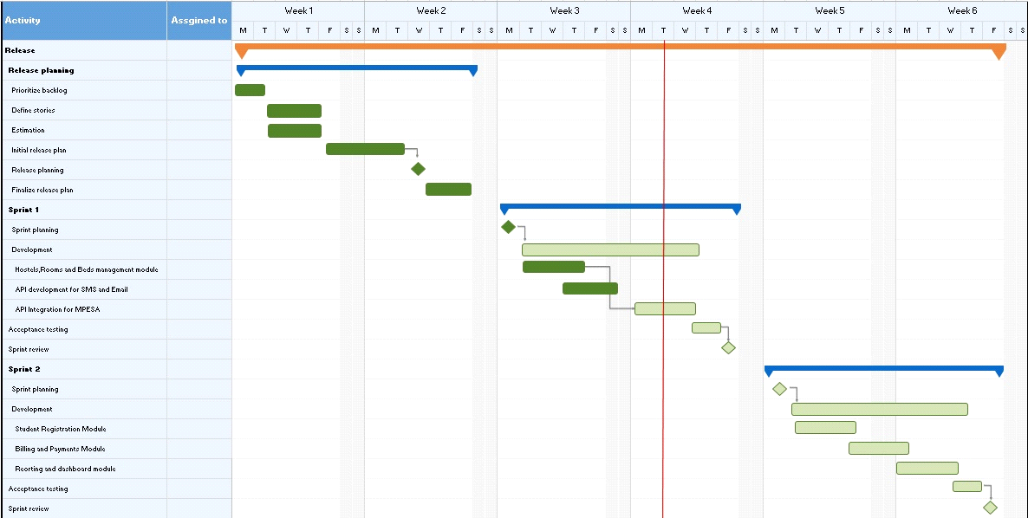

**CHAPTER TWO**

**LITERATURE REVIEW**

**2.0 INTRODUCTION**

In this chapter, the developer intends to review systematically and critically the literature related to the proposed RIAT online Students hostel management system, it will review online systems, billing systems and hostel report generating systems.

**2. 1 MOI UNIVERSITY HOSTELS ONLINE BOOKING SYSTEM.**

The process of applying for a hostel at Moi University , In order for students to book hostels at Moi University, they must follow the Registration process which requires them to have a working email address through which their email will be sent. Fill the needed information correctly and click submit.

After that, the student is required to have paid accommodation fee and has the receipt number with him/her. The student then enters the receipt number and amount paid then click proceed to select the hostel of his/her choice, which should also be of the students gender either male/female

After booking, the room, a student will get the message “wait for the website to validate and then click submit.

This system however is having some limitation since the students are required to pay for the hostel booking in advance, with that kind of process, so many students would pay and with the limited number of hostels, the students may pay and fail to get rooms resulting to fee refunds

The developer for the proposed RIAT students’ online management system will therefore come up with a system that allows students to reserve a space for the stated period and only pay after booking.

**2.2 RESERVATION SYSTEM FOR SHANGRI-LA HOTEL, SINGAPORE**

According to Bemile et al, 2014 Shangri-La Sentosa Resort in Singapore is one of the hotel chains for Shangri-La Corporation. Its official website consists of many useful functions and is purposed at providing the hotel’s information as well as an online reservation system.

To reserve a room, there is a form for guests to fill in their reservation details. In addition to room reservation, guests may fill in another form to make special requests for their reservation.

The proposed RIAT students online management system therefore will apply a lot from this kind of system but because of time factor and being a student hostel system, the developer may not bring in the virtual touring component,

**2.3 KENYATTA UNIVERSITY HOSTELS ONLINE BOOKING SYSTEM**

Accommodation fee is included in the fees indicated on the admission letter.

All KU monies including tuition and accommodation fees are paid ONLY into the KU bank accounts.

(Accommodation Directorate, 2019), The students who already have official KU students email sign in a link to check for hostel allocation status, Once they have signed in with their KU student email, they visit the menu for hostel application and choose either first year student or continuing student. A dialog box appears which requires them to fill in their details and then submit.

Once they submit, they can check their application status menu and select the period they registered for, enter the registration number and submit.

**2.4 GAPS IN THE EXISTING SYSTEMS**

* Lack of Mobile money payment intergration
* For both KU and Moi University, payment is done in advance
* For both KU and Moi University, there is no reservation
* The payment method is semesterwise, and there is no provision for short stay students like school based.

CHAPTER 3

**3.0 INTRODUCTION**

Agile software development methodology is an iterative approach to the design and development of software. The Agile approach embraces the constant changes that occur in the development of technology – allowing the developer to break the lengthy requirements, build, and test phases down into smaller segments, ultimately delivering working software quickly and more frequently.

The iterative nature of agile development means features are delivered incrementally, enabling some benefits to be realized early as the product continues to develop.

Agile development principles encourage active ‘user’ involvement throughout the product’s development and a very cooperative collaborative approach. This provides excellent visibility for key stakeholders, both of the project’s progress and of the product itself, which in turn helps to ensure that expectations are effectively managed.

For RIAT online students’ hostel management system, the system developer will divide the development of this project into three modules

* Room booking module
* Billing module
* Payment Module
* Report generating module

As the developer will be working on the booking module, he/she will also be working on the report generating module and with the agile methodology, testing and documenting will be done all at the same time, the billing module will also be done and even tested, since with agile methodology you do not have to wait to finish everything before testing.

Diagrammatic representation of how agile will work

**3.2 DATA COLLECTION METHODS**

Data was collected using questionnaires, interviews, internet search and observations.

**3.2.1 Questionnaire**

Questionnaires are research instruments that are used to collect data over a large sample Kombo &amp; Tromp, (2006). The questionnaire will be administered to a sample of 200 students’ with closed ended and open ended items. The closed ended items shall be used in order to avoid irrelevance, while the open ended items will be used in order to allow freedom of expression by the respondents.

**3.2.2 Interview**

Interviewing is one of the methods or approaches used in survey research for collecting data (Kathuri &amp; Pals, 1993). The interviews will be used to gather data from the staff concerned with student RIAT hostel management details. The interview schedules will be administered to the house keeping officer, dean of students, Registrar, the principal and the accounts officer

The interview schedule shall include questions that will enable the researcher to obtain clear and detailed information on problems of the current system and the requirements for the proposed RIAT students’ management system.

Interviews allow the researcher to probe the person being interviewed.

**3.2.3 Observation**

The researcher will use unstructured observation checklist to obtain information and aspects of the study not addressed by the questionnaire. These will be done on opening week

Observations are important because some behavior involves habitual routines of which people are hardly aware (Kombo &amp; Tromp, 2006). Observation will also be used to gather more data from the respondents as the researcher will see the experience of the administration of RIAT and student on the manual system processes.

**3.2.4 Internet research**

The Internet was used to check how other systems have been designed and to help the programmer to design a system that meet the standard in the market for the RIAT online students Hostel Management system

**3.3 DATA AND PROCESS ANALYSIS TOOLS**

The developer used the following data and process analysis tools to analyze data, DFD, Use cases, normalization and flowcharts

This helped to make a practical visualization of how the current system works and directed the developer on the best design methods to use so as to develop a feasible system for the RIAT online students hostel management system.

**3.5 HARDWARE AND SOFTWARE SPECIFICATIONS**

Computer

Hardware

* HP laptop Corei5
* 8GB RAM
* 500GB HDD
* 15” Screen
* Keyboard
* Mouse
* LaserJet Printer

Software

* Windows 10 Pro
* MySQL
* PHP
* Bootstrap 4
* jQuery
* Microsoft Office 2016+
* Any Modern Browser (Chrome, Firefox, Opera, MS Edge) that supports JavaScript, CSS3, HTML5
* Visual Studio Code

Tablets and Smartphones

Hardware

* 7” touchscreen for Tablet and 4” for Smartphones
* 1GB RAM
* 2.0GHz Processor

Software

* Any Modern mobile operating system (Android, IOS etc.)
* Any Modern mobile browser that supports HTML5, CSS3 and JavaScript

**CHAPTER FOUR**

**SYSTEM ANALYSIS AND REQUIREMENT MODELING**

**4.0 INTRODUCTION**

In this chapter, the system developer describes how the current system of RIAT hostels work

System analysis modelling tools

**CHAPTER FIVE**

**SYSTEM DESIGN**

**5.0 Introduction**

System design is the process of defining the architecture, components, modules, interfaces and data for a system to satisfy specific requirements. Design works as a bridge between requirement specification and the final product. It is designing of the system which ultimately decides the quality of a system as well. If design is good then the end product is good.

5.1 Design objectives

The design objectives of this system are;

* To produce correct designs within the limitations imposed by the systems requirements.
* To define precisely the required system outputs for Hostel management system
* To determine the data requirements for producing the output
* To determine the methods of capturing data and data inputs
* to design input forms
* to design codification schemes
* To determine the medium and formats of files and databases.
* To devise processing methods and use of software to produce output.

**5.2 PROJECT INFRASTRUCTURE**

This system is menu driven and operates as a batch processing mode as well as real time mode in modules such as hostel reservation, booking, payments and reports.

5.4. Logical design

5.4.1 Logical database design

This is a conceptual abstract design. It involves arranging data into a series of logical relationships called entities and attributes.

The objective of logical design is to create well-structured tables that properly reflect the user environment.

5.4.2 Normalization

Database normalization is a systematic approach of decomposing tables to eliminate data redundancy and undesirable characteristics like insertion, update and delete anomalies. It is mainly used for eliminating redundant data and ensuring that data dependencies make sense i.e. data is logically represented.

* First Normal Form

A relation is said to be in first normal form if the values in the relation are atomic for every attribute in the relation. By this it means that no attribute value can be a set of values or as it sometimes expressed, a repeating group.

* Second Normal Form

A relation is said to be in second normal form if it is in first normal form and it should satisfy any one of the following rules.

1. Primary key is a no a composite key
2. No non-key attribute is fully functionally dependent on full set of primary key.

* Third Normal Form

A relation is said to be in third normal form if it is in second normal form and if there exists no transive dependencies.

Entity Relationship Diagram

The for RIAT online student’s management system is shown below

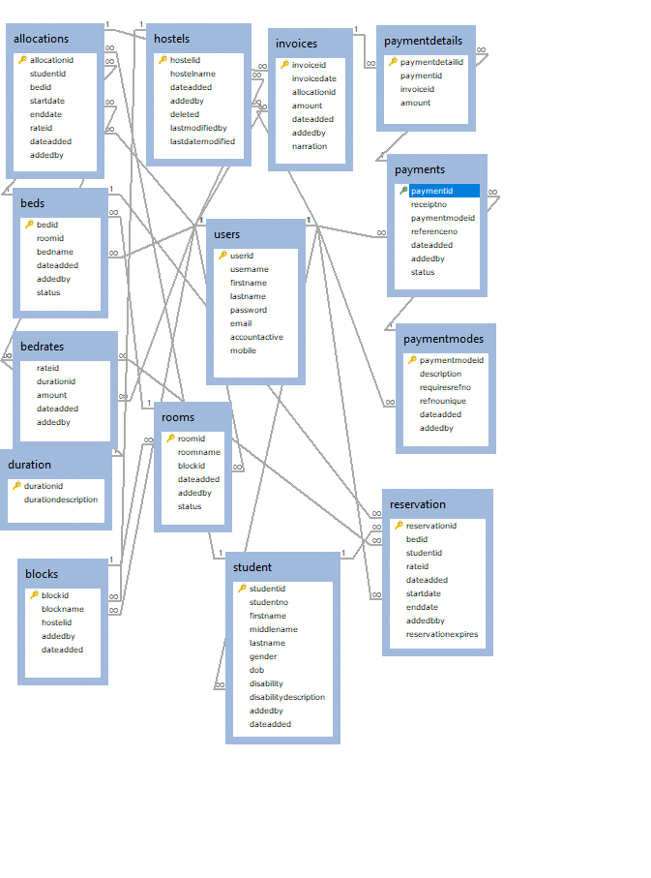

5.5 PHYSICAL DESIGN DESCRIPTION.

The goal of the last phase of the database design, physical design is to implement the database. The SQL statements to create databases are written. The indexes, the integrity constraints and the user's access rights are defined. Finally, the data test the database is added. In parallel with these activities, application programs are designed. The implementation of the programs can start when the database has created and data added to it.

5.5.1 Data Dictionary

This is an organized listing of all the data elements pertinent to the system. The list is meant to give a detailed view of data and how it is used during processing of data. It defines all the data elements within the system by describing the relation between data stores. It is used to describe the characteristics of data including fieldname, data type, field size and description.

Data dictionary

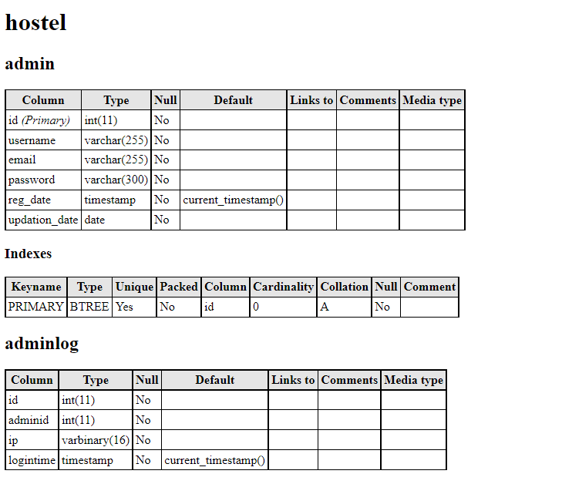

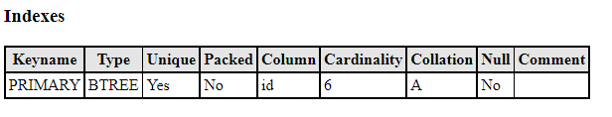

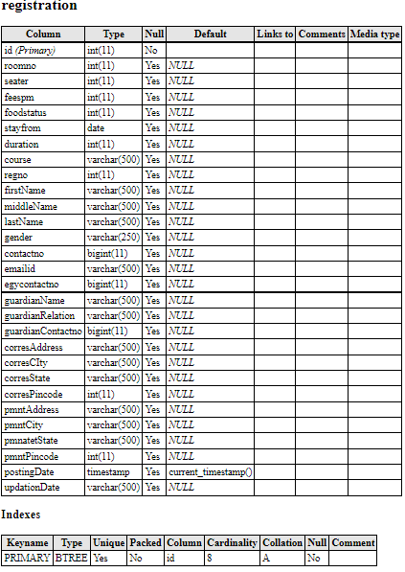

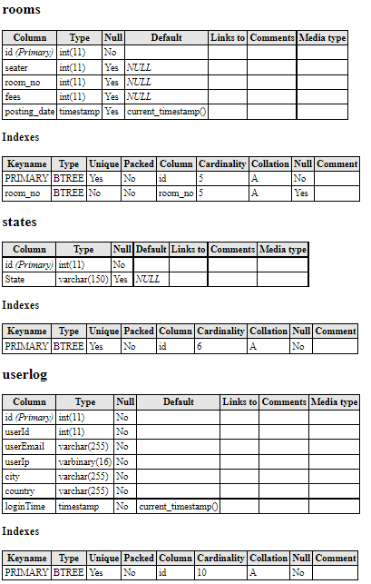

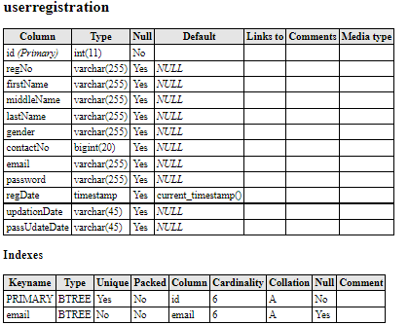

Database Design

Table definition

Admin

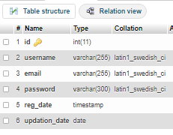

Admin log in

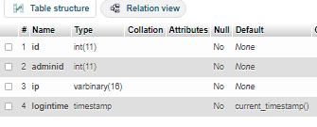

Courses

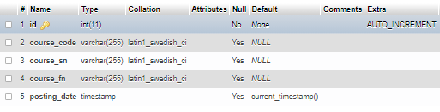

Rooms

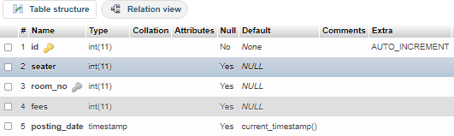

Registration

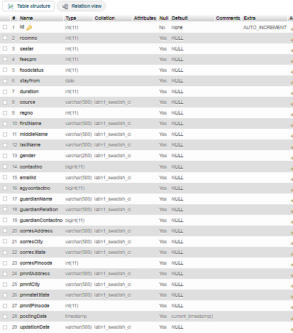

User Login

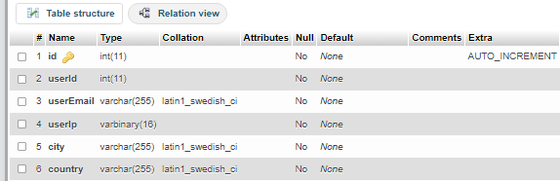

5.5.3 Input Screen Design

The input design for the system are as follows

Admin Login screen

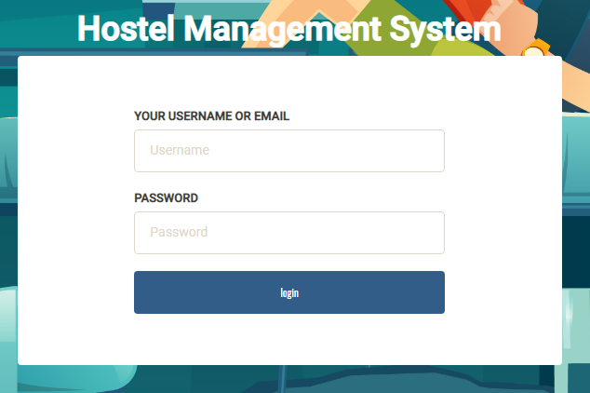

ADMIN LANDING PAGE

Dashboard

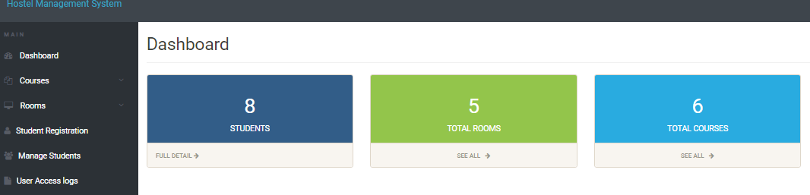

Add course screen

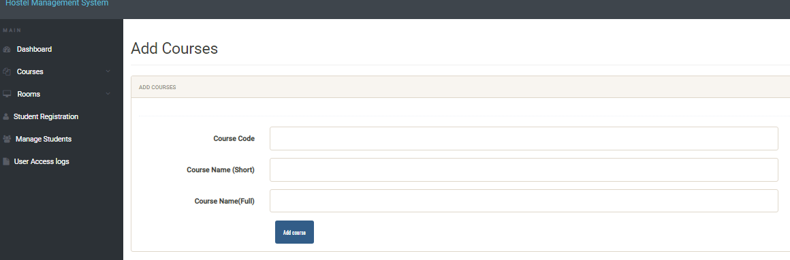

Manage Course Screen

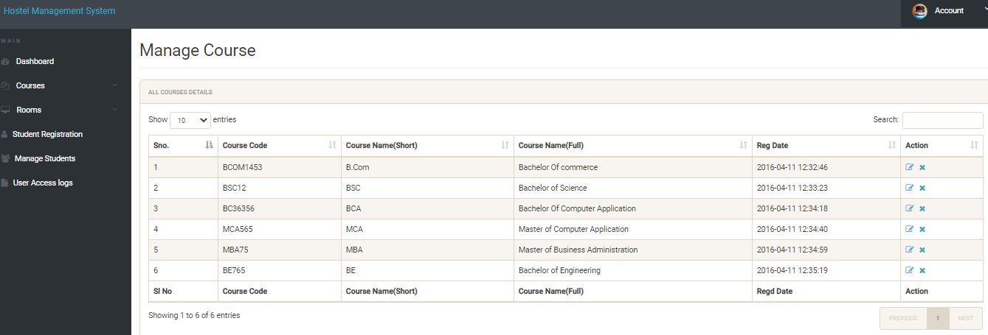

Add Room Screen

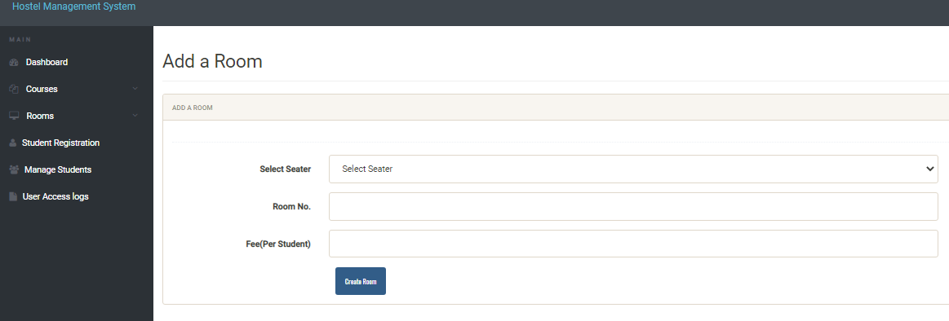

Manage Room Screen

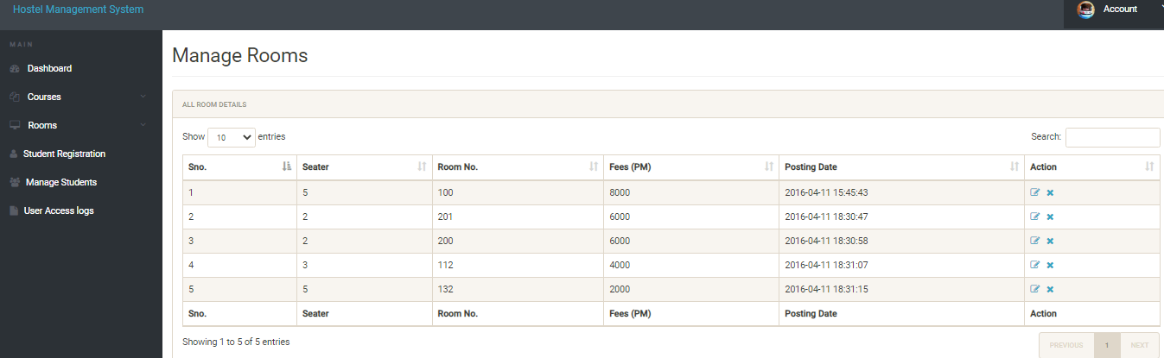

Students Login Screen

Student Landing page

Dashboard

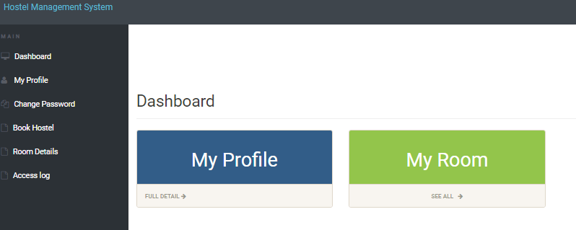

STUDENT REGISTRATION SCREEN

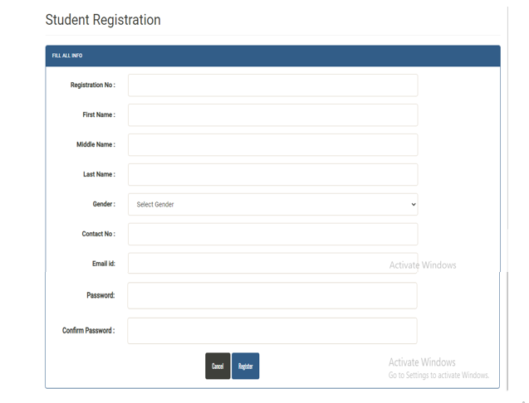

FORGOT PASSWORD SCREEN

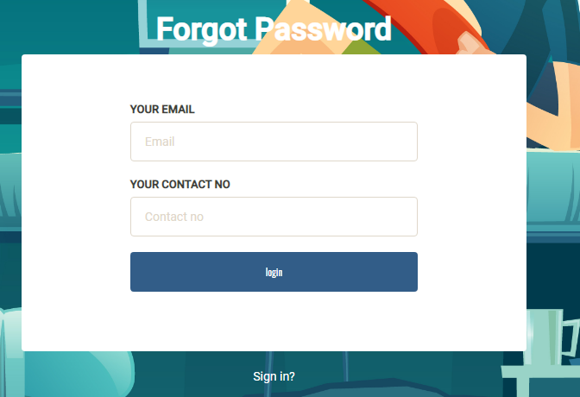

STUDENT LANDING PAGE

5.5.5 OUTPUT SCREENS

5.5.7 Process/Program Design

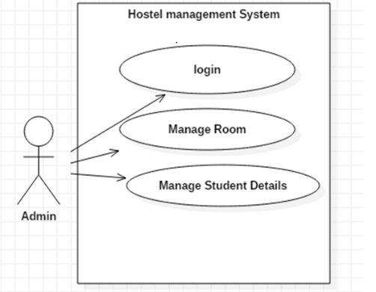

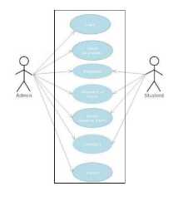

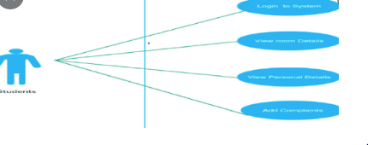

5.5.7.1 System flowchart

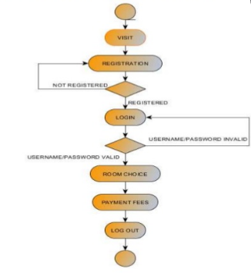

System Sequence diagram

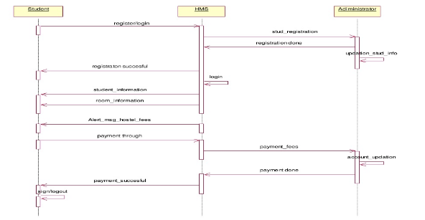System Class Diagram

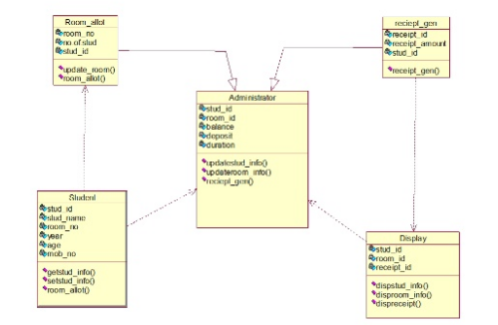

Program Flow chart

Program Flow chart

Program Flowchart

5.5.7.2 Modular program flowchart

It defines the logical steps for the input, output and processing of the information of a specific program. It helps a lot in communicating the main logic of the program.

Modular program flowchart

CHAPTER SIX

SYSTEM IMPLEMENTATION

This is a web based system that is uploaded to ISP server and using the domain provided it is possible for users to login using URL. This is necessary by users at any time provided they have access to a computer device and internet connection. There is no installation done by the user. Hand held devices such as phones with iOS, Android, Linux, Ubuntu, windows and blackberry OS can be used to access the system

* 1. **Tools used for coding and testing**

|  |  |  |
| --- | --- | --- |
| # | Development environment | |
|  | Development operating system | Windows 10 |
|  | Database | MSSQL Server 2008 |
|  | Database client | MSSQL Server Native client |
|  | Web server | Apache 2.4 |
|  | Development environment (IDE) | VS code |
|  | Package management | Composer |
|  | Version control | Git, Bitbucket |
|  | Development languages, libraries and API references | |
|  | Backend | PHP 7.2 |
|  | Frontend | HTML 5, JavaScript, CSS 3, JSON |
|  | Libraries and API references | jQuery 3.2, jQuery Mobile, Bootstrap 4, Google maps API |
|  | Testing Environment | |
|  | JavaScript enabled Browser | Google Chrome, Mozilla Firefox, Opera |

**Testing tools**

* Requirements Tracking Tool
* Bug Tracking Tool
* Automation Tools
  1. **Test Environment**

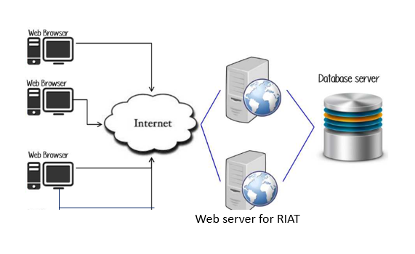

* 1. **System test plan**

**The below is the test plan that was used by the developer.**

|  |  |  |  |  |
| --- | --- | --- | --- | --- |
| **Test plan** | | | | |
| **AUTHOR: Lucy Wagoro** | **CONTACT: 0729023458** | | **Final Date for comments: 21/12 /2020** | |
| **Product under test**  RIAT online students hostel management system | **Test objectives.**   1. To help Identify bugs and plan for fixing 2. Prevent defects 3. To ensure the end results meets the system objectives 4. To gain customer acceptance | **Participants**   1. Ten students 2. Two members of the dean’s office | **Test Tasks**   1. Build verification test 2. Funtional test 3. Security test 4. End to end use 5. User Acceptance test | **Responsibilities**   1. Identify bugs 2. Identify defects 3. Comment on preferred changes in terms of UI/UX 4. Comment on how friendly system is 5. Submit their comments to lucywagoro@gmail.com |
| **Test Tools** | | | | |

## 6.3 Testing

Standard test cases were used, with data provided by the tester. Sample test cases and test data for the system are listed Appendix in C. Sample program listing is provided in appendix D

* 1. **Training**

With the introduction of RIAT students online hostel management system, the following people were trained, Deans office staffs, Accounts Office staffs and students.

The staffs were trained on both student and admin rolls whereas students were only trained on students’ rolls

Importance of training

This prepared the users for a smooth transition to the new system by training them on how and what data to be input, execute the program, process data and get the required reports.

Users appreciated the need for change and overcame the fear of unknown and anxiety brought by fear for not being able to cope up with the system.

The following methods were used for training.

1. **User manuals:**

This is a document that has all the necessary instructions guiding the users on how to use the system. For instance, The User (Admin/ Student) were given a manual on how to operate the system depending on the access level

INSTALATION ENVIRONMENT

The system is hosted online, the client should install the following software environemt in order to use the system efficiently;

* Aserver(XAMPP) The system has been developed using PHP( Aserver side programming language) which requires that the user must have a server installed either locally or remotely. This environment is provided by installing XAMPP and configuring properly to allow the user to log in.
* An operating system – Microsoft Windows, Linus or MAC
* A web browser Mozilla, google chrome, or any other

Installation procedures

Step 1

**Download**

XAMPP is a release made available by the non-profit project Apache Friends

<https://www.apachefriends.org/download.html>

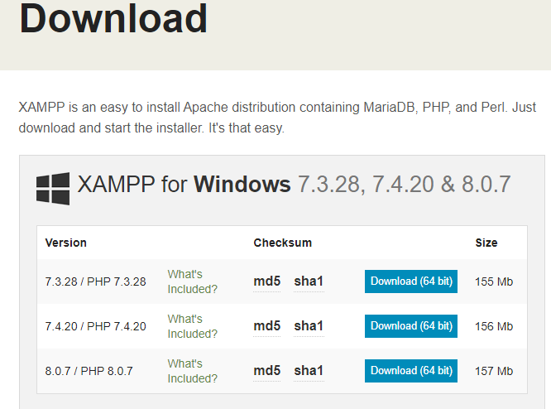

Step 2

Run the XAMPP executable file

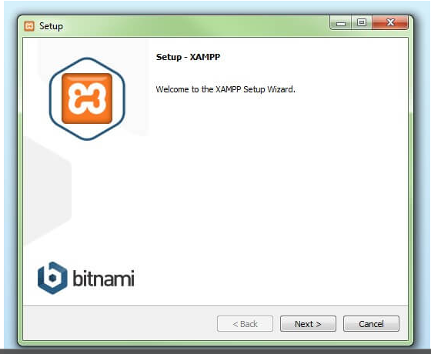

**Step 3**

**Deactivate any antivirus software**

#### 

#### Step 4: Start the setup wizard

After you’ve opened the .exe file (after deactivating your antivirus program(s) and taken note of the User Account Control, the start screen of the XAMPP setup wizard should appear automatically. Click on ‘Next’ to configure the installation settings.

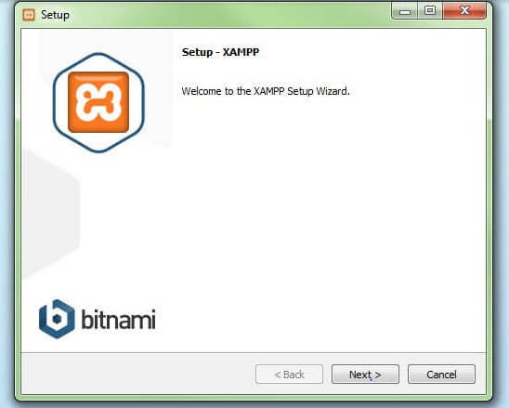

#### Step 4: Choose software components

Under ‘Select Components’, you have the option to exclude individual components of the XAMPP software bundle from the installation. But for a full local test server, we recommend you install using the standard setup and all available components. After making your choice, click ‘Next’.

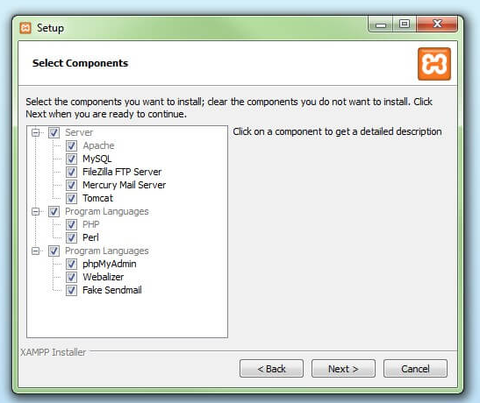

#### **Step 5: Choose the installation directory**

In this next step, you have the chance to choose where you’d like the XAMPP software packet to be installed. If you opt for the standard setup, then a folder with the name XAMPP will be created under C:\ for you. After you’ve chosen a location, click ‘Next’

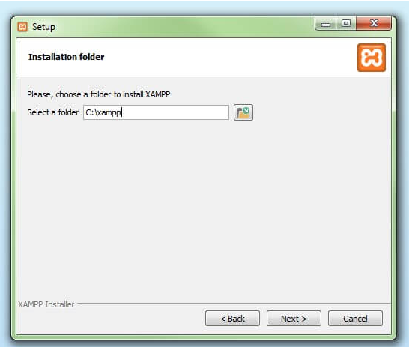

Step 6

Start installation

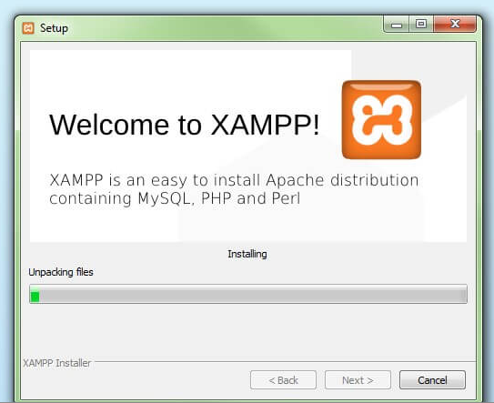

**Step 7**

**Complete installation**

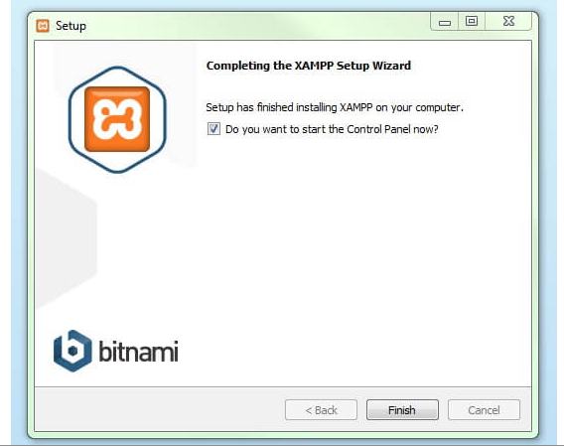

## The XAMPP Control Panel

Controls for the individual components of your test server can be reached through the XAMPP Control Panel. **The clear user interface**logs all actions and allows you to start or stop individual modules with a single. The XAMPP Control Panel also offers you various other buttons, including:

* **Config:** allows you to configure the XAMPP as well as the individual components
* [**Netstat**](https://www.ionos.com/digitalguide/server/tools/introduction-to-netstat/)**:** shows all running processes on the local computer
* **Shell:** opens a UNIX shell
* **Explorer:** opens the XAMPP folder in Windows Explorer
* **Services:** shows all services currently running in the background
* **Help:**offers links to user forums
* **Quit:**closes the XAMPP Control Panel

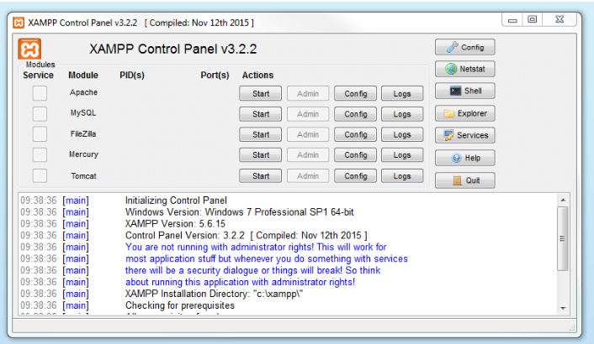

**Step 8.**

Click Start on apache and MySQL to run

**Step 9.**

Once apache and Mysql is running

Download and Unzip the hostel management system on file on your local system.

2. Put this file inside xampp/htdocs/ .

**Step 10.** Database Configuration

ReachMySQL database via [localhost](https://www.ionos.com/digitalguide/server/know-how/localhost/)/phpmyadmin/

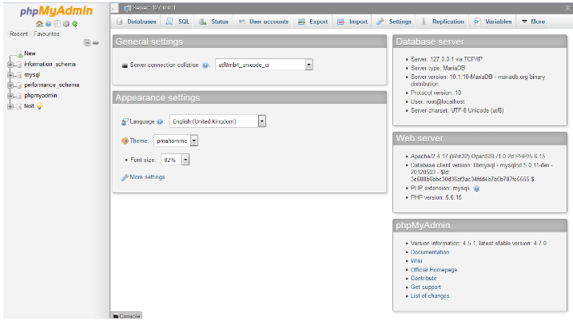.

Step 11

Click new to create a new database called hostel

Step 12

Import database hostel.sql

Step 13

Open Your browser put inside browser?://localhost/hostel/?

Login DetailsOpen Your browser put inside browse?http://localhost/hostel/?

**Login Details**

Put in log in details for admin

For a first-time login use

Login Details for admin : admin/Test@1234

b. **Individual hands-on instructor.**

An instructor, in this case the system developer, walked each individual user through the process of performing a certain task and answer the questions. This made the user more conversant with the system if such problems occur.

* 1. **System Change-over technique**

Conversion is the process of changing from the old system to the new system. It must be properly planned and executed. There are various methods of changeover that include parallel system conversion, direct system conversion, pilot system conversion and phase conversion.

However, for this system, parallel system conversation was used. This is the process of converting from old system to a new system by running the new system simultaneously with the old system. Both the old system and the new system operates simultaneously for a certain period of time. The resultant outputs from each system are then compared and any differences is reconciled. The time necessary for parallel conversion depends on the number processing discrepancies detected and time required to make revision in the new system.

This method has the following advantages.

* It ensures that in case of any problems in using the new system, the organization can still fall back on the old system without the loss of data, time and money
* The user can learn the new system while still using the old system.

CHAPTER SEVEN

LIMITATION CONCLUSION AND RECOMMENDATIONS

## 7.1 Introduction

A significant amount of time and effort went into researching for the project, while the rest of time and effort was used on documenting the findings and implementation of the project. Most of the research was done through reading documentation and observation, implementation was done using object-oriented system analysis and design. This chapter details the limitations encountered while working on the project, the conclusions drawn and some significant recommendations that can advance the system.

## 7.2 Limitations

Some of the challenges and limitations encountered within the course of the project are;

1. There was a lot of information to be reviewed and observations to be made from the current system; this posed a challenge in acquiring applicable information for the project within a limited time.
2. Some of the issue raised in the problem statement could not be converted into a systematic computerized solution. There are scenarios, which cannot be solved using computerization only and that remain a challenge.
3. Changing how things are usually done in the workplace is always a challenge. This project is not an exception to the fact. The objective of the project was to improve the operations of the current system, but the institution may be reluctant to adapt to using the system citing numerous reasons.
   1. **Conclusion**

Even the all the scope has not been achieved as was proposed. The project objective has been achieved to a higher percentage. This project will solve many problems that were experienced by the old system.

The automation of RIAT students hostel management system has reduced double allocation of beds significantly, accommodation is guaranteed to the students by reservation on a first come first serve basis, it has reduced fee refunds since payment are now made only after billing and bed allocation.

* 1. Recommendations.

The developer of the system recommends that RIAT administration should consider adopting this system since the benefits coming along with it are more.